Background to give HDD: As it’s very hard, and it have circular disk, and to read data continuously it’s moving in circular direction.

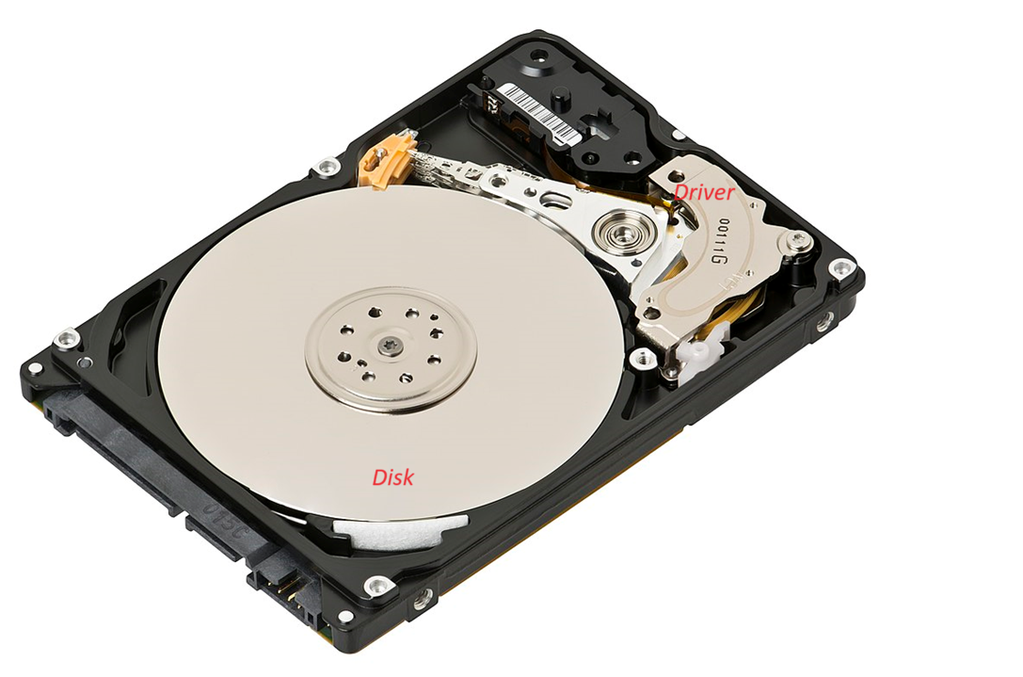

All the information would be stored in hard drive.

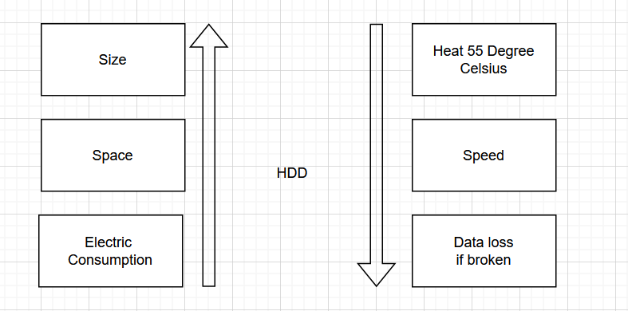

SSD: A solid-state drive (SSD) is a [solid-state storage](https://en.wikipedia.org/wiki/Solid-state_storage) device. It provides [persistent](https://en.wikipedia.org/wiki/Persistence_(computer_science)) data storage using no moving parts. It is sometimes called semiconductor storage device or solid-state *device*; it is also called solid-state *disk* because it is [frequently interfaced to a host system](https://en.wikipedia.org/wiki/Solid-state_drive#Host_interface) in the same manner as a [hard disk drive](https://en.wikipedia.org/wiki/Hard_disk_drive).

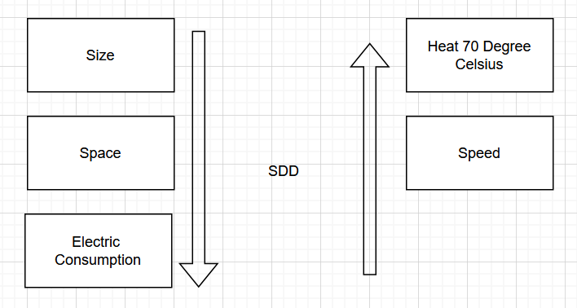

To list the harddisk

